Comments 2
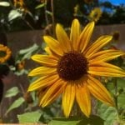
By: Carina
I really like how you can really see the texture of the flower in this photo. It doesn’t look like you said woah this is a flower and just took a quick picture, it looks like you took your time to take a quality photo.
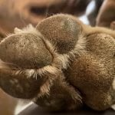
Photo By: Emma
I like the way this picture shows every cervix of the dogs paw. Not only does it show the paw and have emphasis on that but also the texture of the fur.
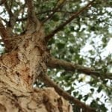
By Lilly- I like how in the photo you can see each individual piece of texture on the bark I also like the way you can see the texture by the different shades of brown shown.
By: Mazzy- In this image you can see many different shapes. I like how the signs stand out from the sky and each signs draw your attention because they are all different.

