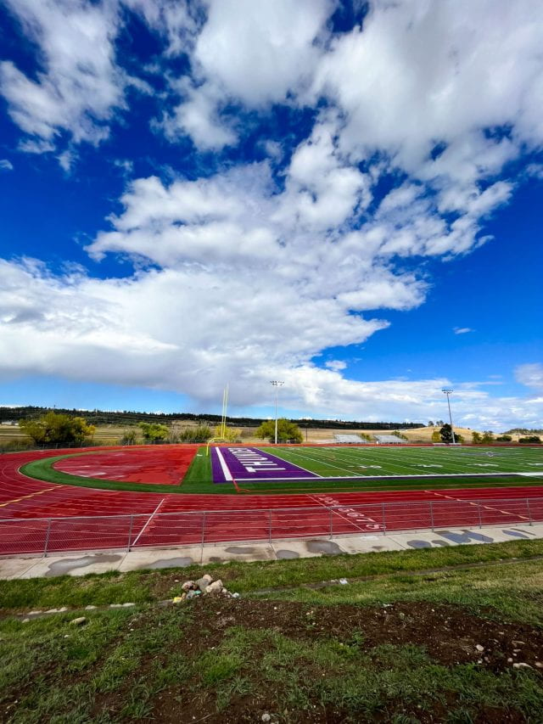Photo By: Brendan Gray
I like the contrast of colors in this image. The red stands out against the green of the field and pops next to the blue sky. It looks like the clouds are jumping out at you. 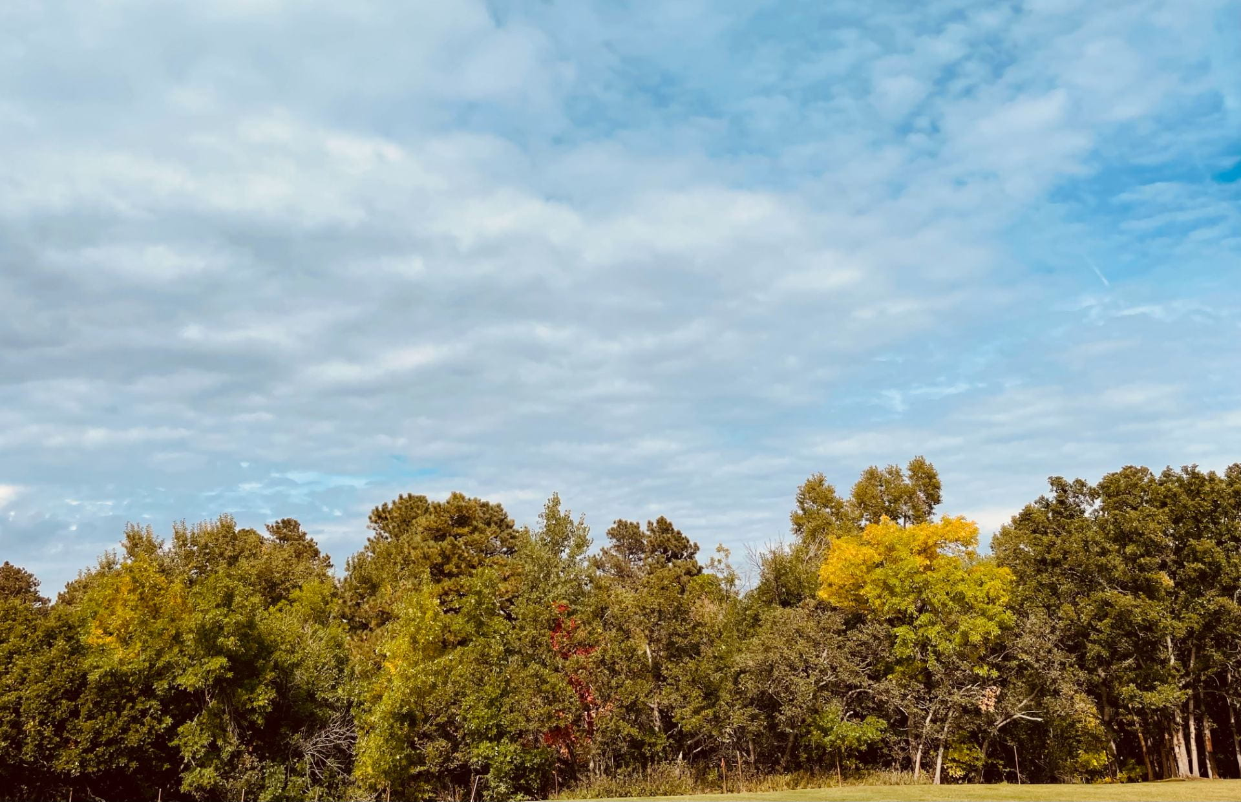 Photo By: Garret George
I like the peaceful feeling I get when looking at this image. The yellows, reds, and greens of the trees just blend together to provide a happy feeling. The sky is a light blue with the little fluffy clouds throughout. It’s altogether peaceful.
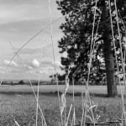 Photo By: Keyanna Kirk
I like the way the grass shows through the camera lens. I also appreciate the fact that you took the photo from a different angle.
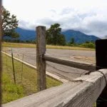 Photo By: Mazzy Miller
I like the way my eyes are drawn to the fence, yet it does not distract from the landscape. This photo is very nice to look at.

