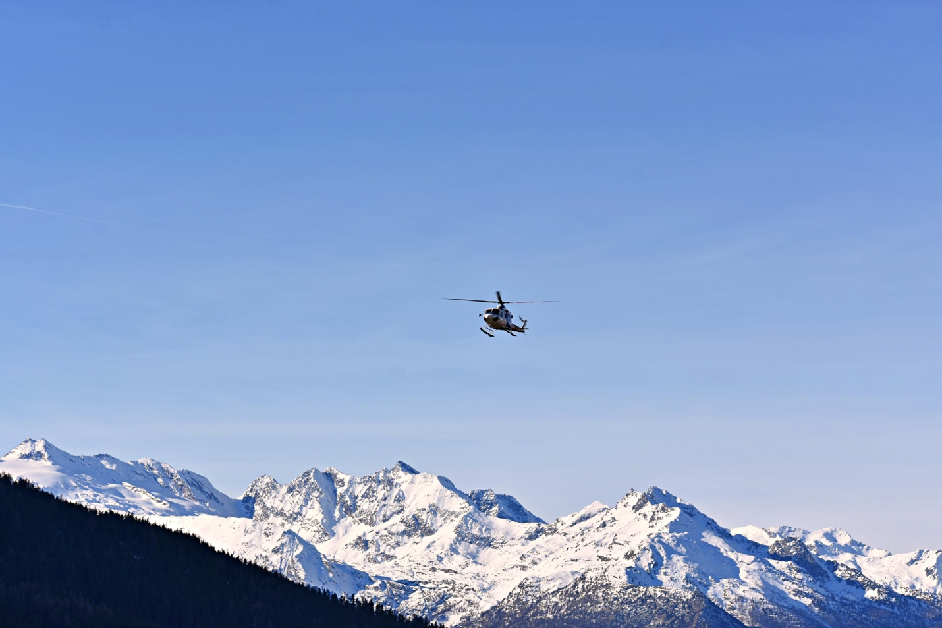
Photo By: Dids

That was the day my world changed, the day I almost lost my best friend. Beep* Beep* Beep* The alarm sounds at 3am. I wake up on the floor at my best friend’s house, it’s time to go skiing. I had stayed at her house the night before after basketball and we probably stayed up way too late. By 3:30 we were out the door ready to head up to the mountain. We spent the whole car ride singing and laughing totally unaware of what would happen that day. To us it seemed like a normal day, but I will never forget seeing her hauled down the mountain behind a snowmobile and then fly off over the mountains. That was the day my world changed, the day I got a new perspective on life.

